***PROJECT REPORT***

**Project Name**: Car sealing System

**Course Code**: CSE110

**Course Title**: Object Oriented Programing (OOP)

**Section**: 05

**Submitted to**:

Tanni Mitra

Lecturer

Department of Computer Science and Engineering

East west university

**Submitted by:**

**Name**: Mohammad Hasan Azhar

**ID**: 2020-1-60-080

**Name**: Samiha Masura

**ID**: 2020-10-60-066

**Name**: Md.Abid Sarkar

**ID**: 2020-1-60-196

Index

Topic Page Number

1.fornt page ………….…………………………………..1

2. Index …………………………………………………2

3.Admin panel Access ……………………………3

4. Problem Statement …………………………….4

5.All Features

1. Manu type interface …………………………..5
2. Administrator security ………………………..5
3. Add cars ……………………………………………6
4. update price …………………………………7
5. remove car …………………………………….8
6. user login ……………………………………9
7. search by brand ……………………………10
8. BY condition ………………………………...11
9. by price ……………………………...12
10. Data in file ………………………… …..13

Admin panel Access:

**User Name**: Hasan

**Password:** 123

Problem Statement:

**I. Simple Explanation:**

The Cars sealing system project is used in a car sealing Company. The application stores all the information about cars. And put the information in the data base. And let the user find perfect car for them to buy. The application made simply in design that anyone can use it easily. It has an admin panel to avoid unnecessary and fake data entry. Only admin panel can store data about car and consumer buy car.

**II. System Requirements:**

(Recommended)

**Processor**: Intel Core i3/ AMD Ryzen 3 1300

**RAM:** 1 GB

**Operating System**: Windows 7 or higher/ Mac/ Linux

**IDE**: NetBeans 8.2 or Higher/ intellij 13.2

**JVM**: 8.00

**III. System Design:**

The project design in manu bar type. where user or admin panel type 1/2/3 and go to the option he/she want. We also design that if admin input data that store in data file.

**iv. Implementation:**

This is Cars sealing system app which can help you to store information’s about cars data on a car sealing company. It can also let user to buy car for them and fine the best car from many cars.

**v. All Features:**

**Feature 1:** Manu type interface

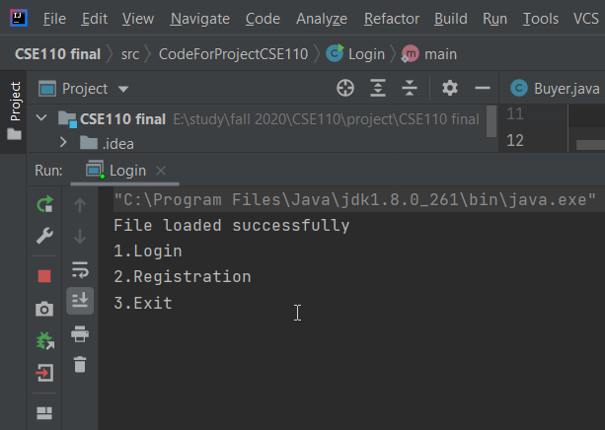

**Feature 2**: Administrator security

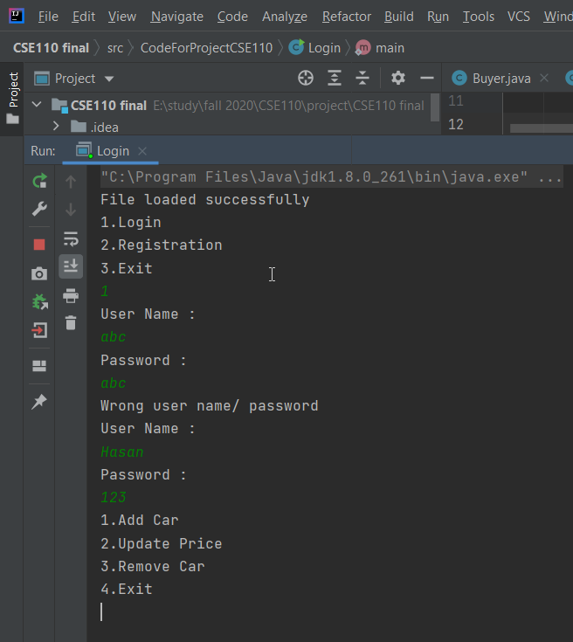

Feature 3: Add cars

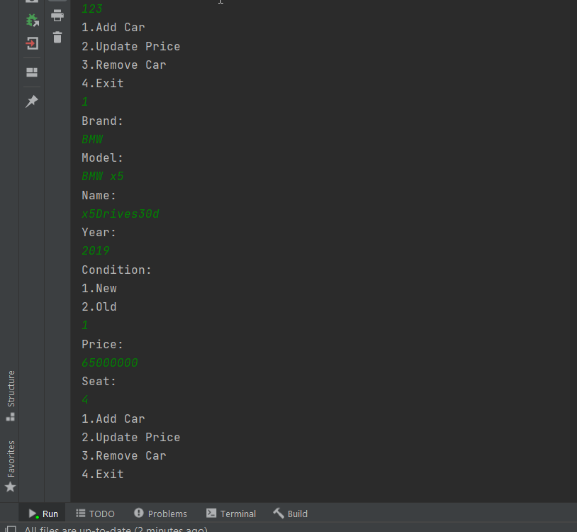

**Feature 4**: update price

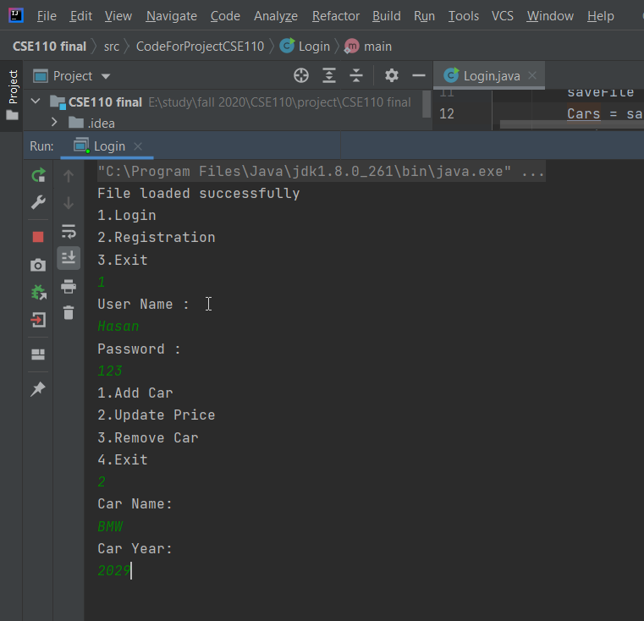

**Feature 5**: remove car

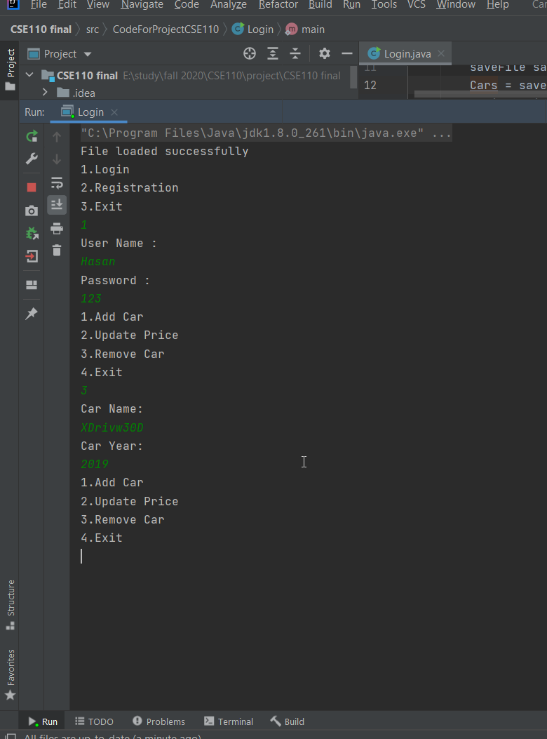

**Feature 6**: user login

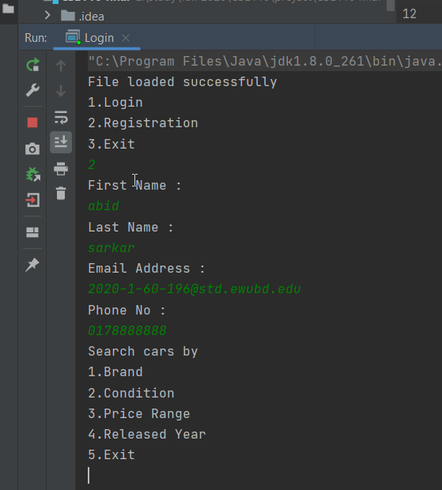

**Feature 7:** search by brand

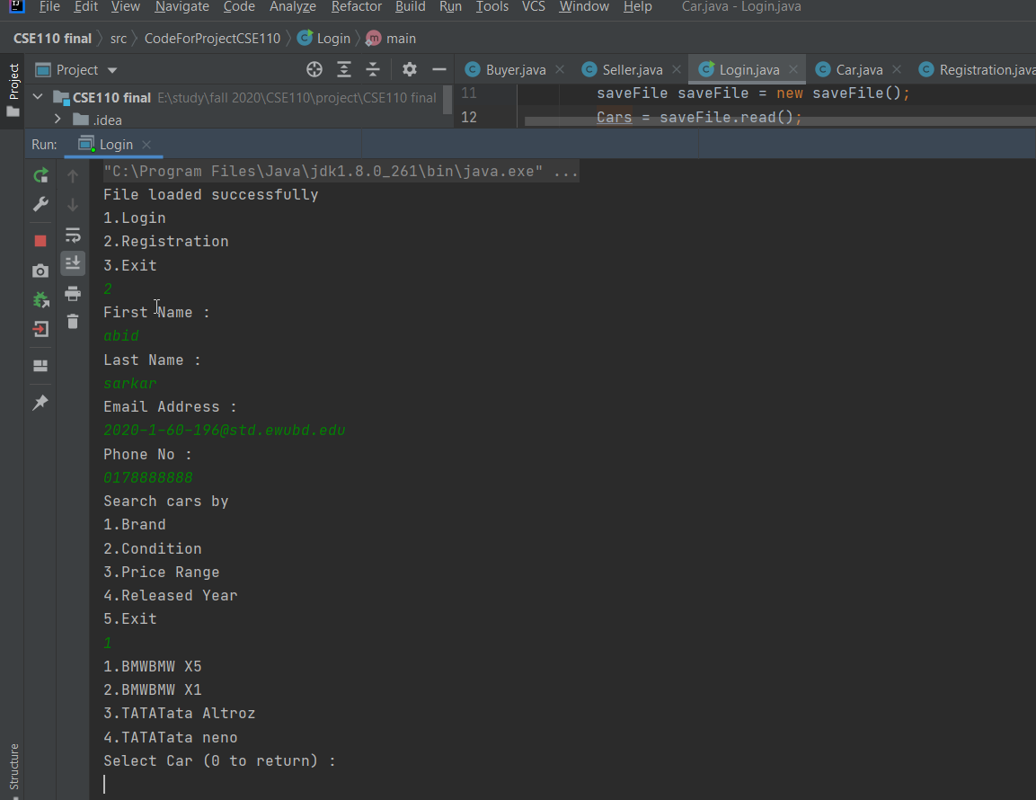

Feature 8:BY condition

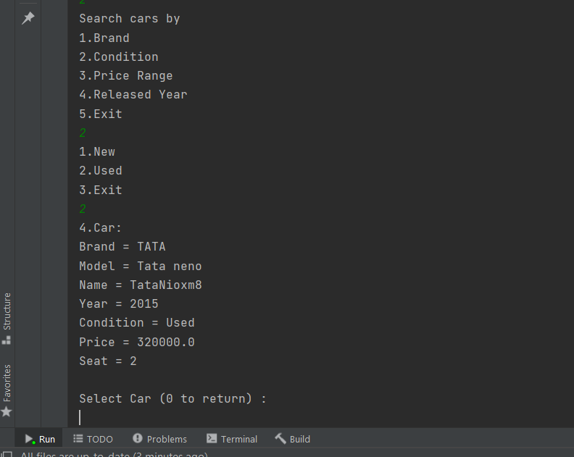

**Future 9**: by price

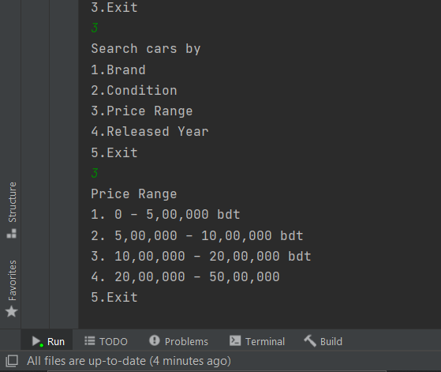

**Feature 10**: Data in file

